KONECTA

Name: Tarek Adel Ali Badee

Task 1

DevOps

Contents

1 A list of all Git commands: 3

2 Screenshots: 4

3 Final calculator.py file after the fix: 13

4 Written Explanations: 14

***4.1 Git log and git diff*** 14

***4.2 Git stash was necessary*** 14

***4.3 Choice between git reset --hard and git revert*** 14

***4.4 Difference between git stash pop and git stash apply*** 14

# 1 A list of all Git commands:

git init

git add calculator.py

git commit -m "init: Add calculator with add, subtract, multiply"

git add calculator.py

git commit -m "feat: Add divide function with zero check"

git add calculator.py

git commit -m "fix: Optimize subtract function logic (introducing bug)"

git log

git diff c310e1a

git stash

git revert c310e1a

git stash pop

git add calculator.py

git commit -m "feat: Re-apply experimental Fibonacci print"

git push -u origin main

# 2 Screenshots:

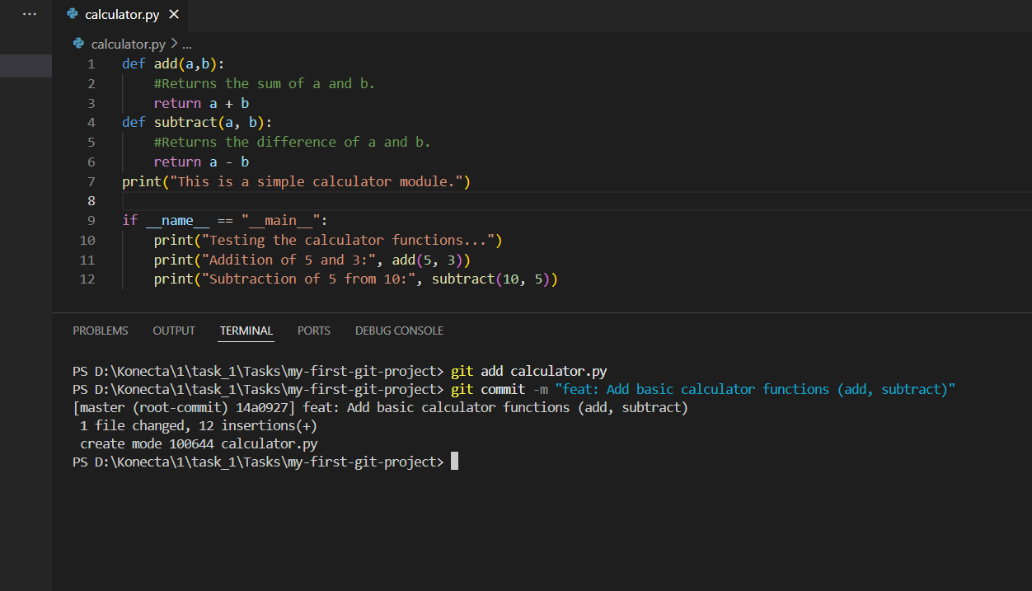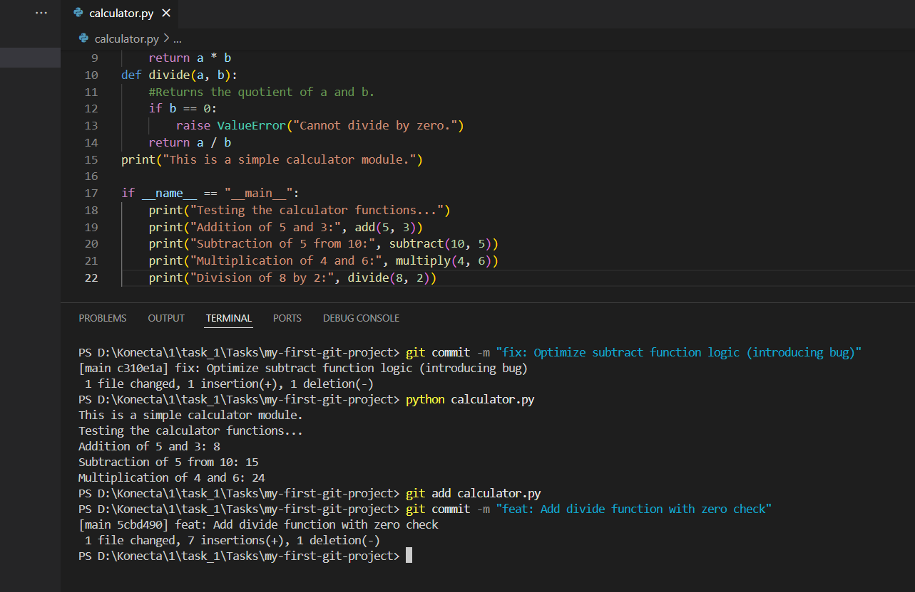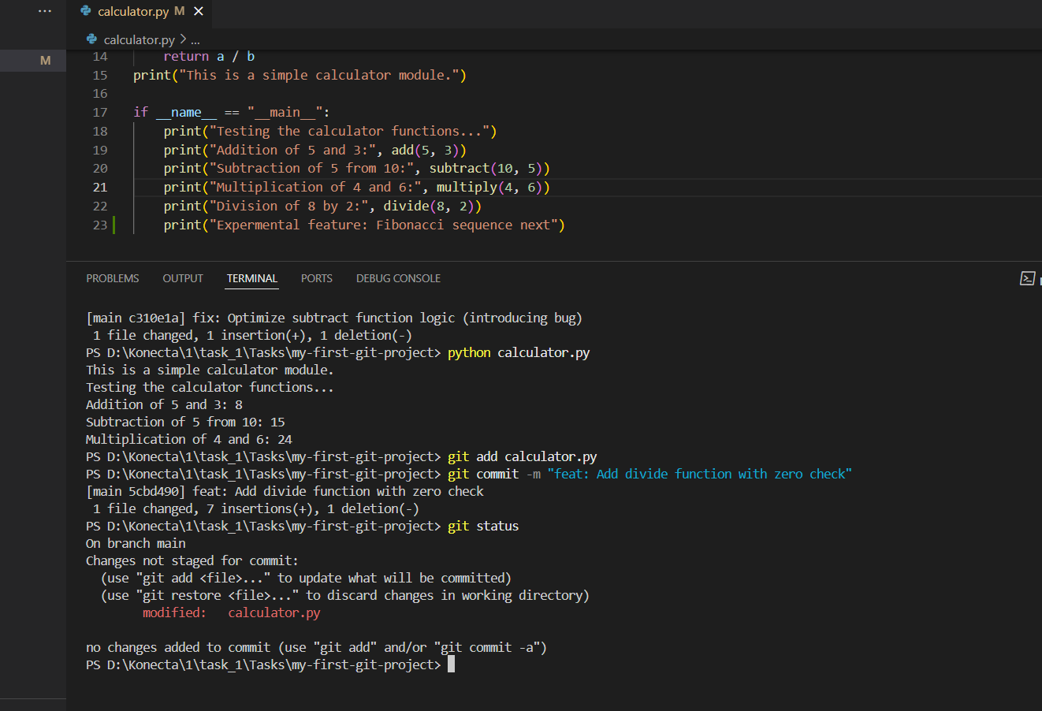

# 3 Final calculator.py file after the fix:

def add(a,b):

    #Returns the sum of a and b.

    return a + b

def subtract(a, b):

    #Returns the difference of a and b.

    return a - b

def multiply(a, b):

    #Returns the product of a and b.

    return a * b

def divide(a, b):

    #Returns the quotient of a and b.

    if b == 0:

        raise ValueError("Cannot divide by zero.")

    return a / b

print("This is a simple calculator module.")

if __name__ == "__main__":

    print("Testing the calculator functions...")

    print("Addition of 5 and 3:", add(5, 3))

    print("Subtraction of 5 from 10:", subtract(10, 5))

    print("Multiplication of 4 and 6:", multiply(4, 6))

    print("Division of 8 by 2:", divide(8, 2))

    print("Expermental feature: Fibonacci sequence next")

# 4 Written Explanations:

## ***4.1 Git log and git diff***

Git log showed me the history of commits, git diff c310e1a showed the exact change in the subtract function

## ***4.2 Git stash was necessary***

Git stash to save temporarily the code until solve the issue then go back to full code and combine them together.

## ***4.3 Choice between git reset --hard and git revert***

Revert because it safely undoes a commit without deleting history, reset --hard would remove history and uncommitted changes.

I’d use reset --hard only in personal or local-only projects

## ***4.4 Difference between git stash pop and git stash apply***

Both restore stashed changes, but stash pop removes from the stash list after applying, stash apply keeps in stash.